**LAB 7: Diodes**

Name:

**Objective:**

To examine the characteristics of diodes.

**Learning Outcomes:**

1. Able to obtain and analyze the characteristics of diodes

2. Able Calculate the resistance in forward bias and reverse bias.

3. Able to deduce relationship between capacitance value and dc voltage value.

**Instrument/Component:**

Oscilloscope

Function Generator

Resistor: 1kΩ

Diodes: PN junction (1N4004/1N4148/BY127/OA79)

Capacitor: 100uF (polarity)

**Prelab: Biasing of PN junction Diode**

**Forward bias operation**

The P-N junction supports uni-directional current flow. If +ve terminal of the input supply is connected to P-side and –ve terminal is connected the n side, then diode is said to be forward biased condition. In this condition the height of the potential barrier at the junction is lowered by an amount equal to given forward biasing voltage. Both the holes from p-side and electrons from n-side cross the junction simultaneously thereby decreasing the depleted region. This constitutes a forward current (majority carrier movement – diffusion current). Assuming current flowing through the diode to be very large, the diode can be approximated as short- circuited switch. Diode offers a very small resistance called **forward resistance (few ohms).**

**Reverse bias operation**

If negative terminal of the input supply is connected to p-side and –ve terminal is connected to n-side then the diode is said to be reverse biased. In this condition an amount equal to reverse biasing voltage increases the height of the potential barrier at the junction. Both the holes on P-side and electrons on N-side tend to move away from the junction there by increasing the depleted region. However the process cannot continue indefinitely, thus a small current called reverse saturation current continues to flow in the diode. This current is negligible; the diode can be approximated as an open circuited switch it offers a very high resistance called **reverse resistance (few Kilo ohms)**.

**Static Resistance:** The opposition offered by a diode to the direct current flowing forward bias condition is known as its **DC forward resistance** or Static Resistance. It is measured by taking the ratio of DC voltage across the diode to the DC current flowing through it at an operating point.

**Dynamic Resistance:** The opposition offered by a diode to the changing current flow I forward bias condition is known as its **AC Forward Resistance**. It is measured by a ratio of change in voltage across the diode to the resulting change in current through it for an operating point P.

**Average Resistance**: Same as dynamic resistance but measured between extremities.

**Diode current equation**

The volt-ampere characteristics of a diode explained by the following equations:



Where

*I* = current flowing in the diode,

*I0* = reverse saturation current

*V* = voltage applied to the diode,

*VT* = volt- equivalent of temperature = k T/q = T/ 11,600 = 26mV (@ room temp)

*η*=1 (for Ge) and 2 (for Si)

**Task 1: Forward Bias and Reverse Bias**

1. Connect the circuit as shown in Figure 7.1 (PN Junction diode with ammeter in series with the diode).

If

+ Vf -

1k

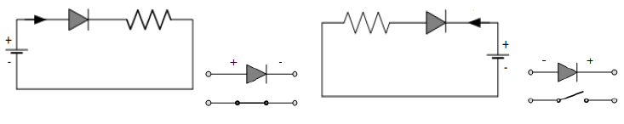

Vs

**Figure 7.1**

1. Initially vary voltage **Vs** in steps of **0.1 V**. Once the current starts increasing vary **Vs** in steps of 0.02**V** and note down the corresponding readings **V*f*** and **I*f***.
2. Tabulate different forward currents (ID=If) obtained for different forward voltages (VD) in Table 7.1.
3. Connect the circuit as shown in Figure 7.2 (Point contact diode in series with ammeter).

- Vr +

Ir

1k



Vs

**Figure 7.2**

1. Vary **Vs** gradually in steps of **1V** from **0V** to **12V** and note down the corresponding readings **V*r*** and **I*r***.
2. Tabulate different reverse currents (ID=Ir) obtained for different reverse voltages (VD = Vr) in Table 7.1.

**Table 7.1**



1. Plot the V-I characteristics and calculate the resistance levels.



1. Obtain the following parameters from the graph:

**a) Forward Bias of PN Junction Diode:**

Cut-in Voltage V =

Static forward Resistance =

Dynamic Forward Resistance =

Average Resistance =

**b) Reverse Bias of Point contact diode:**

Reverse Static Resistance =

Reverse Dynamic Resistance =

**Task 2: Half Wave Rectifier**

1. Construct the circuit shown in Figure 7.2.The diode used in this part of the experiment is IN4004.

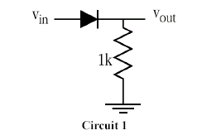

**Figure 7.2**

1. Examine its operation when excited by a sinusoidal input source of Vin of 2V amplitude and frequency of 500 Hz. Observe using an oscilloscope the voltage waveform across the 1 kΩ resistor.
2. Sketch the waveform of Vin and Vout.

Sketch:

1. How does the observed result compare to the theoretical result?
2. Note down the peak output voltage, the clipped voltage at reverse bias and the transition input voltage values.

Peak voltage : _________________

Clipped voltage : _________________

Transition voltage : _________________

1. Modify your existing circuit to include the 100µF capacitor as shown in circuit in Figure 7.3. (*This is an electrolytic capacitor, make sure you connect it in a proper polarization).*

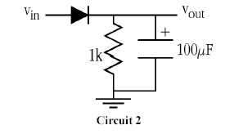

**Figure 7.3**

1. Sketch the output signal. Note the peak-to-peak ripple voltage and dc voltage values and compare them to the theoretical results.

Sketch:

Theoretical Peak-to-peak ripple voltage: ___________________

Measured Peak-to-peak ripple voltage: ___________________

Theoretical dc voltage: _________________

Measured dc voltage: _________________

1. What is the function of this capacitor in determining the output signal?
2. Replace the capacitor with other capacitor values. Observe and record the dc values and the ripple voltages.

Answer:

1. How do the capacitor values affect the ripple voltage and the dc voltage values?

Answer: